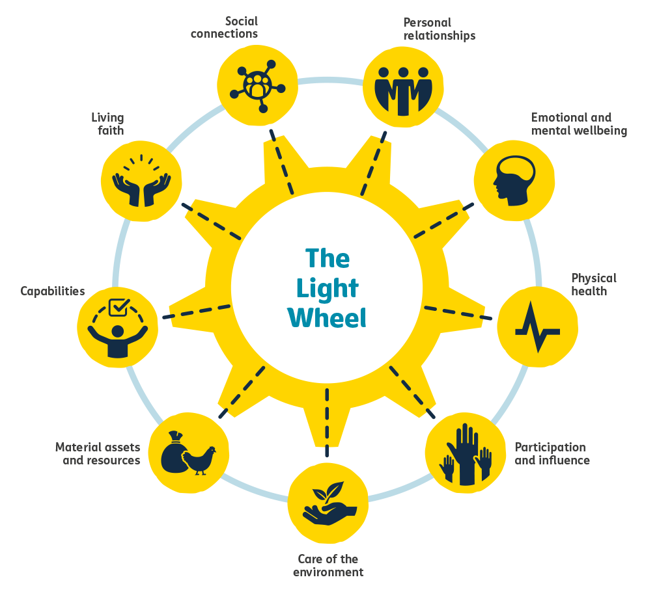
3.1.10 Light Wheel report template
[Add organisation/church name]
[Add country]
[Add month and year]

Table of contents
Page
Executive summary 3
Introduction 4
Introduction to your programme 4
Introduction to this report 4
Methodology 5
Analysis 5
Participants 7
Location 7
Demographics 7
Programme involvement and impact 8
Results 9
Spoke 1: Living faith 10
Spoke 2: Social connections 11
Spoke 3: Personal relationships 12
Spoke 4: Participation and influence 13
Spoke 5: Emotional and mental wellbeing 14
Spoke 6: Physical health 15
Spoke 7: Material assets and resources 16
Spoke 8: Capabilities 17
Spoke 9: Care of the environment 18

Discussion 19
Conclusions and recommendations 19
Conclusions 20
Recommendations 21

Executive summary
[Remove the guidance below once you have added your executive summary]

The executive summary is where you provide an overview of what tools you used, how you used them, and what your key findings are. It is helpful to give some insight into the type of people who participated and a short introduction to your work and why you are writing this report.
- Explain your methodology in one or two sentences, eg how you selected people to interview for a Light Wheel survey or who participated in group discussions etc (as relevant). You can also include how you used the validation tools and the tools for reviewing the context (if relevant).
- You can then provide further narrative or discussion on your findings and what you think is most significant for your audience.
- You could add a picture or a graph here, if it makes your summary stronger.

Summary

Insert text here: no more than two pages

Introduction
[Remove the guidance below once you have added your own text under each heading]

We recommend that your introduction has four parts: an overview of your programme, a summary of your aims in using the Light Wheel tools, an explanation of how you used the tools, and a description of how you did your analysis.

Introduction to your programme

Introduce your programme (eg CCT). What are its main objectives and where has it been implemented? If you are working with partners, explain how you collaborate to achieve your aims.

Introducing our programme

Insert text here: one to three paragraphs

Introduction to this report

Explain how you used the Light Wheel tools and why. What kind of a report is this (baseline, midline, learning review etc)? Give a summary of your aims in using the tools and what you hoped to accomplish by gathering and analysing your data.

Introducing this report

Insert text here: one to three paragraphs

Methodology
Explain how you used the Light Wheel tools. Create a separate section for each tool that you used and include the following details:
- Where and when did you collect data using this tool?
- Who participated?
  - If you used the Light Wheel survey, also include: how you sampled, what the size of your sample was, how many interviews you conducted, and the confidence interval and confidence level you used to create your sample.
- How was data collected? Did you use data collectors? Did they work in pairs or alone? Where did you conduct survey interviews? Did you conduct group discussions at the same time or later? How did you collect data for your validation tools and tools for reviewing the context?
- You can add photographs throughout the report, if you feel they will help explain your methodology and results
If relevant, describe any limitations, biases or problems that you had in collecting data. For example, was there a holiday that disrupted things or an unexpected change to your data-collection plan? Were there any groups who were more difficult to reach?
Don’t make this section too long. It should give your reader some confidence in how you collected your data so they understand how to interpret the results, and can trust that the results can be generalised.

How the Light Wheel tools were used

Insert text here: about three paragraphs, up to half a page

Analysis
Explain here how you did your analysis. You can provide details on how you analysed data from each tool, and how you brought the datasets together to confirm or challenge findings. Explain what you did where findings from one tool challenged findings from another tool. How did you resolve this? Is further research needed to explore those contradictions more fully? In this section you can also explain if you used any software (eg KoBoToolbox or Excel) to support your analysis of your Light Wheel survey.

How our data was analysed

Insert text here: up to half a page

Participants
[Replace the guidance below with your own text under each heading]

Location
You can first give an idea of where you used the Light Wheel tools so that your reader can place the results in context. Add a map, for example, of where your programme area is and the communities where you used the Light Wheel tools. Or insert a table that explains the number of participants per location and which tool they participated in:
Location | Tool | Number of participants
egg Montone district | eg Group discussions | 3 groups of 12 people  Men’s group, women’s group, youth group
egg Montone district | eg Transect walk | 5 participants

Demographics
You can then explain the demographics of those who participated in the Light Wheel tools you used
eg age, gender, faith affiliation and disability. Be sure to include only information for which participants have given permission. Include a version of the table below repeated for each Light Wheel tool, adapting each table (eg adding or removing rows) to reflect the demographic categories you used for each tool.
Demographic questions | %
Percentage of people in different age groups | Add rows for age brackets eg under 18, 18–30 etc
Percentage of female/male participants | Female
Percentage of female/male participants | Male
Percentage of people within each religious group | Add rows for different faiths
Percentage of people in each marital status category | Add rows for different categories
Percentage of people who have disabilities
Etc

Programme involvement and impact
Next, you can describe how your interviewees were involved in the programme (eg what percentage were programme participants), and what they think have been its key impacts, both for them as individuals and for the church. This is a great place to bring in some direct quotes from participants if you have them. Be sure to share only information that you have permission to share.

Programme involvement and impact

Insert text here:

Results
[Remove the guidance below once you have added your results]
In this section, you will present your results for the nine aspects of wellbeing (or spokes). This means that you will share your key findings from all of the Light Wheel tools you used as they relate to each aspect. You can first give a summary of your findings for the aspect, and then choose some additional headings from the list below to give more details. In the tables per Light Wheel spoke that follow, delete any sections you don’t want to use.

Summary of your findings
You might like to use the defining themes for each aspect of wellbeing to help explain your findings. See Descriptions of the nine aspects (Resource 3.1.3) and the Themes and Indicators (Resource 3.1.4) which you can access via Tearfund Learn. The table below is an example of what this might look like:

eg Living faith
Theme (group discussion) | Indicator (Light Wheel survey) | Results
Importance of faith | The percentage of people who feel that their faith is important to them

Contradictions and confirmations using different tools:
When you did your analysis, you would have identified some findings that are similar between the tools you used (validated) and other findings that may be different between the different tools (contradicted). This section is where you can share these confirmations and contradictions, without needing to interpret them yet (as this will follow in the section called ‘Discussion’).

If relevant, comparison of findings with baseline:
If this is a midline/endline report, you can compare the findings you have identified now with those that were found in the baseline.

If relevant, comparison of findings between locations:
If you looked at different communities in different parts of a district, country or region, you can compare the findings by geography and consider how where a person lives affects their experience of this aspect of wellbeing.

Disaggregation of findings:
You can disaggregate your findings further to explain how the findings differ between different types of people eg by age, gender, programme involvement.

 | Spoke 1: Living faith  Our faith in God and the way our daily lives are shaped by it

Summary of your findings:

Insert text here

Contradictions and confirmations using different tools:

Insert text here

If relevant, comparison of findings with baseline:

Insert text here

If relevant, comparison of findings between locations:

Insert text here [Rural] [Urban] [Differences between locations]

Disaggregation of findings:

Insert text here [Gender] [Age] [Ability] [Faith affiliation]

 | Spoke 2: Social connections  The extent to which we connect with and support  each other as a community

Summary of your findings:

Insert text here

Contradictions and confirmations using different tools:

Insert text here

If relevant, comparison of findings with baseline:

Insert text here

If relevant, comparison of findings between locations:

Insert text here [Rural] [Urban] [Differences between locations]

Disaggregation of findings:

Insert text here [Gender] [Age] [Ability] [Faith affiliation]

 | Spoke 3: Personal relationships  The love, security and respect we find in marriages,  families and close friendships

Summary of your findings:

Insert text here

Contradictions and confirmations using different tools:

Insert text here

If relevant, comparison of findings with baseline:

Insert text here

If relevant, comparison of findings between locations:

Insert text here [Rural] [Urban] [Differences between locations]

Disaggregation of findings:

Insert text here [Gender] [Age] [Ability] [Faith affiliation]

 | Spoke 4: Participation and influence  Using our voice to influence decision-makers and make  our communities a better place

Summary of your findings:

Insert text here

Contradictions and confirmations using different tools:

Insert text here

If relevant, comparison of findings with baseline:

Insert text here

If relevant, comparison of findings between locations:

Insert text here [Rural] [Urban] [Differences between locations]

Disaggregation of findings:

Insert text here [Gender] [Age] [Ability] [Faith affiliation]

 | Spoke 5: Emotional and mental wellbeing  How we feel about ourselves and the opportunities  we see in our future

Summary of your findings:

Insert text here

Contradictions and confirmations using different tools:

Insert text here

If relevant, comparison of findings with baseline:

Insert text here

If relevant, comparison of findings between locations:

Insert text here [Rural] [Urban] [Differences between locations]

Disaggregation of findings:

Insert text here [Gender] [Age] [Ability] [Faith affiliation]

 | Spoke 6: Physical health  Looking after our bodies and having access  to good-quality health services

Summary of your findings:

Insert text here

Contradictions and confirmations using different tools:

Insert text here

If relevant, comparison of findings with baseline:

Insert text here

If relevant, comparison of findings between locations:

Insert text here [Rural] [Urban] [Differences between locations]

Disaggregation of findings:

Insert text here [Gender] [Age] [Ability] [Faith affiliation]

 | Spoke 7: Material assets and resources  Using our creativity to make the most of our resources,  make new resources, and share our resources with others

Summary of your findings:

Insert text here

Contradictions and confirmations using different tools:

Insert text here

If relevant, comparison of findings with baseline:

Insert text here

If relevant, comparison of findings between locations:

Insert text here [Rural] [Urban] [Differences between locations]

Disaggregation of findings:

Insert text here [Gender] [Age] [Ability] [Faith affiliation]

 | Spoke 8: Capabilities  Developing and using our gifts and skills to make a living,  serve others, and bring about positive change in our lives

Summary of your findings:

Insert text here

Contradictions and confirmations using different tools:

Insert text here

If relevant, comparison of findings with baseline:

Insert text here

If relevant, comparison of findings between locations:

Insert text here [Rural] [Urban] [Differences between locations]

Disaggregation of findings:

Insert text here [Gender] [Age] [Ability] [Faith affiliation]

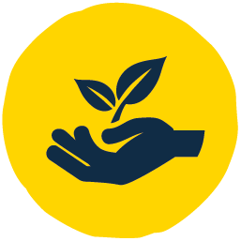 | Spoke 9: Care of the environment  Looking after and enjoying the natural world, easing the risks  and protecting resources for future generations

Summary of your findings:

Insert text here

Contradictions and confirmations using different tools:

Insert text here

If relevant, comparison of findings with baseline:

Insert text here

If relevant, comparison of findings between locations:

Insert text here [Rural] [Urban] [Differences between locations]

Disaggregation of findings:

Insert text here [Gender] [Age] [Ability] [Faith affiliation]

Discussion
[Remove the guidance below once you have added your discussion]

In this section, you want to answer the question: What does this all mean?
Sometimes, reports will group all the results (as this template does), and then discuss the results as a whole at the bottom of the report. However, you can also break down the results and discussion into separate sections for each aspect of wellbeing.
This is the section of the report where you can interpret the findings. If there were any surprising results, you can list them here. If there were any contradictions between tools that you had to explore further, you can explain what insight that gave you and how it challenged your original assumptions.
You can refer back to the objectives of your study and of your programme. How do the findings connect to those aims?

Discussion

Insert text here: two to four pages

Conclusions and recommendations
[Remove the guidance below once you have added your conclusions and recommendations]

Finally, at the end of the report, you want to draw some conclusions and make some recommendations based on your findings.
Conclusions
Write a short introductory paragraph first to describe how you arrived at these conclusions. What conclusions could you draw from the findings? Your conclusions should be relevant to the people you interviewed, the audience of the report (whoever is reading it), and to the programme.
If you have particular learnings based on your data, you could also specifically draw them out, either in bullet points or a numbered list. Some of your conclusions might be about further investigation or understanding you still need to get. Some might be successes or failures so far.
Finish with one or two summary sentences. Try to make this section clear enough so that if this is all a reader has time to look at, they could understand the main conclusions you have drawn from your findings and your work with the Light Wheel tools.

Conclusions

Insert text here: up to one page

Recommendations
Based on the learnings and conclusions above, what recommendations do you have?
You could also call this section ‘Next steps’. Consider dividing your recommendations into different categories to make them easier to read eg:
Recommendations for the programme:
- What areas are really working well and should continue to be implemented?
- What is not working well and how should it be adjusted to increase impact?
Recommendations for the church/community/participants:
- What are the next steps for those who participated in this programme/members of the local churches in this area?
Recommendations for future use of the Light Wheel tools:
- This could be specific learning that you have about how the tools were used, reflecting again on what worked well and what could be improved.
Recommendations for Tearfund:
- These will probably be linked to the recommendations above but you may have specific recommendations for Tearfund that can be helpful for similar programmes or where the Light Wheel tools are being used in the same way that you have used them here.

Recommendations

Insert text here: up to half a page

Before finalising your report, it is important to ensure that you communicate your findings,
conclusions and recommendations with each stakeholder group. You can find more information
on this in Part 5: Communicate. After communicating your findings, you can make changes based
on what stakeholders have added and finalise your report. It can then be disseminated more widely
and shared for others to learn from.

Available in the Light Wheel toolkit at: learn.tearfund.org/LW5
Remember to adjust your page numbers once your report is complete.
Available at: learn.tearfund.org/LW3-1

