3.2.5 Discussion conclusions template
General information
Name and location of community:
Date of group discussion:
Names of facilitators:
Group type (eg men, women, youth):
Number of participants:
Scoring process (eg voting, consensus, average):
Any other details on process followed:

Record of the discussion
Discussion notes |  |  | Maturity model score  and justification
Spoke title:
Spoke title:
Spoke title:
Spoke title:
Spoke title:
Spoke title:

Spoke title:
Spoke title:
Spoke title:

Now plot the scores on the maturity model diagram
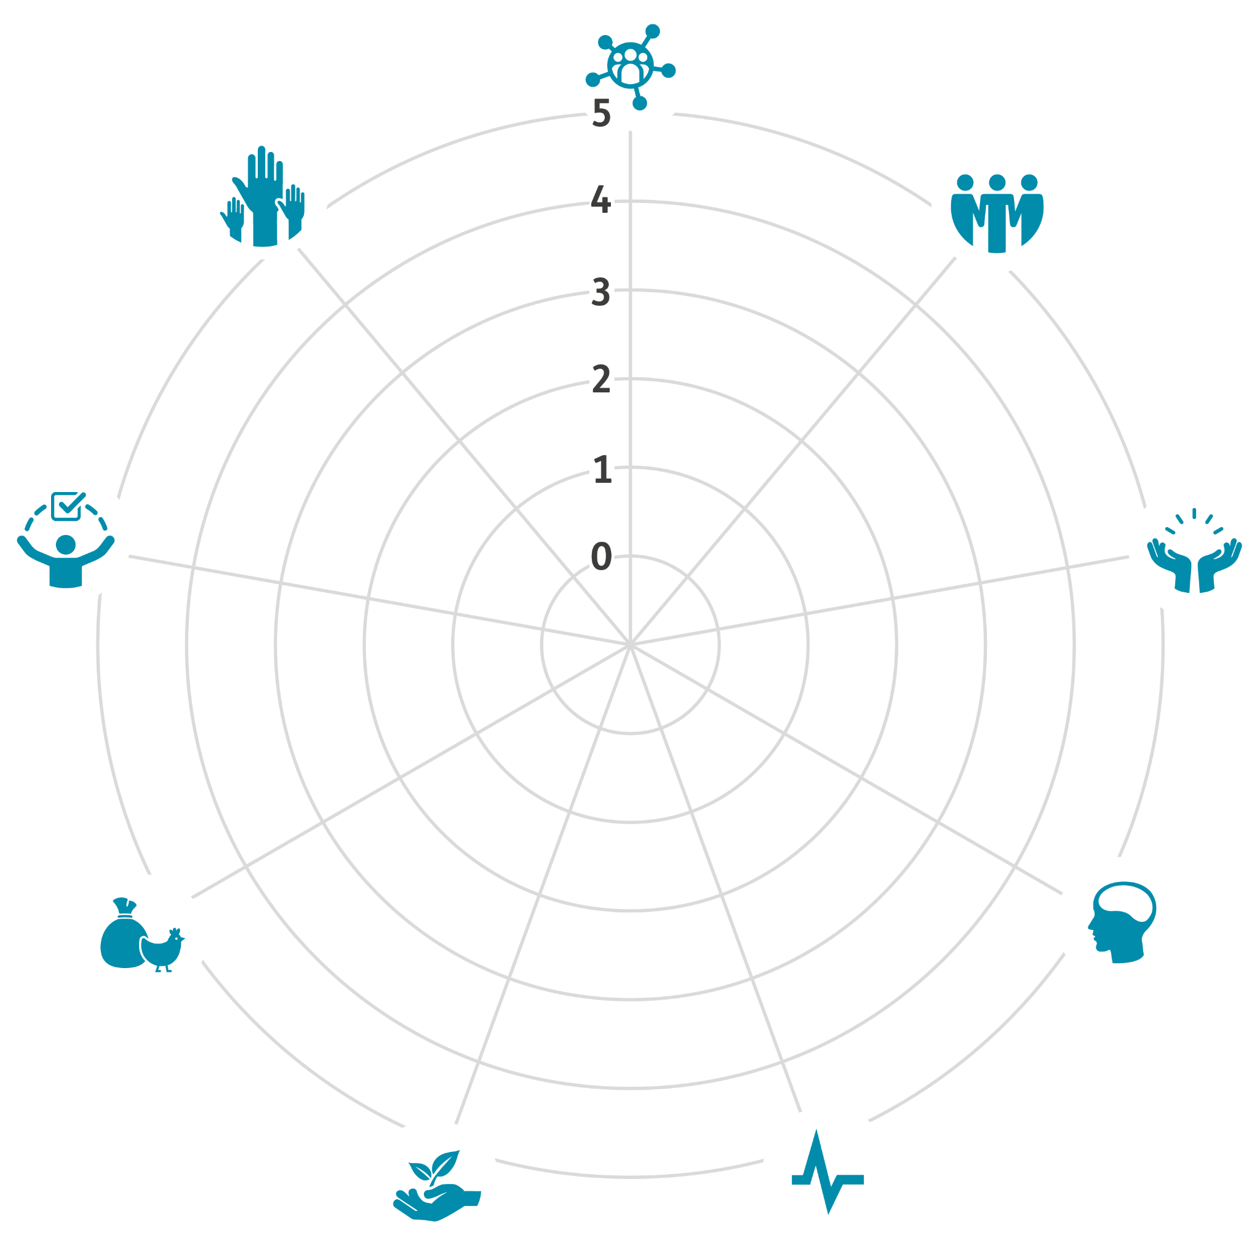
Explanation of the diagram:

