Data management plan template

About
This data management plan template is part of a toolkit designed to help (I)NGO practitioners apply research ethics to evidence-generating activities, including research and evaluation. The other tools in the toolkit are:
- Do research ethics apply to your project? (a checklist)
- Ethics risk assessment (a template)
- Participant information sheet and consent form (a two-part template)

Figure 1 (below) shows how the tools relate to the different phases of a research or evaluation project cycle.
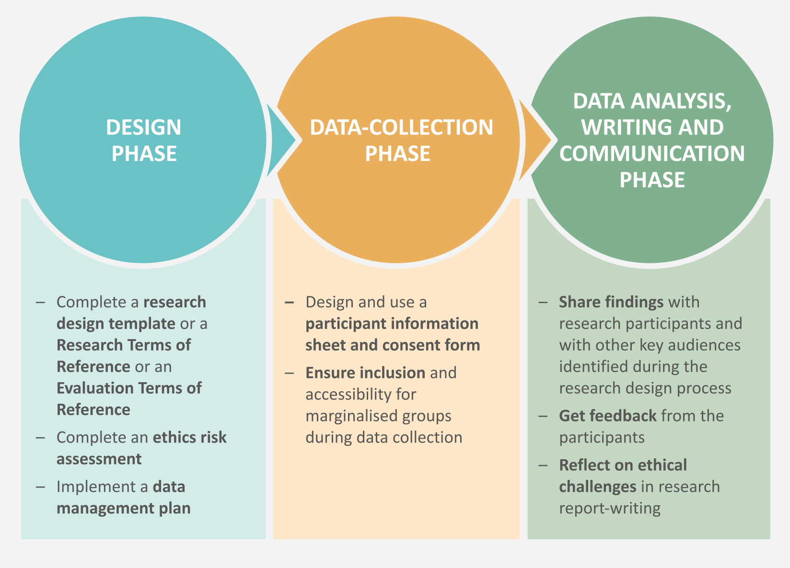

You can find the rest of the toolkit here. By following this link, you will also be able to read and download a guide to the principles that underlie the tools. Research ethics is about more than just the tools that we use: it concerns the moral integrity with which we conduct research or evaluations, and the extent to which we minimise the risk of harm associated with these activities, while maximising their benefits.

Responsible data management
Whenever we collect, analyse and/or communicate data, in order to do so ethically, we must consider responsible data management. As explored in the guide, responsible data management is the practice of gathering, storing and using information in such a way that we maintain the principle of ‘Do No Harm’. The possible effects of our work with data are far-reaching: we must minimise the likelihood of those effects being negative, and maximise the likelihood that they will be positive. Data offers us opportunities to better understand people’s needs and behaviours and to increase efficiency and impact. When used sensitively and appropriately, the information we collect, including the stories, perspectives and experiences of those people we serve, can help bring about tremendous positive change. Data exercises power. It can create, redistribute, amplify or disrupt power. It can entrench certain perspectives and privilege certain actors, but it can also empower new voices and approaches. It can reveal and unravel atrocities, but it can also expose the vulnerable and marginalised, and exacerbate existing stigmas.
Managing data responsibly is a challenge. Therefore, proactive advance planning is very important. A data management plan, completed during the research or evaluation design phase alongside an ethics risk assessment, provides a useful framework for this.

How to use
In the tool you will find a series of questions: respond to each in turn. As you do so, you may find it helpful to refer to the following further resources and guidance: The Engine Room, Oxfam’s Responsible data management training pack and Principles for Digital Development.
This document is a master template, so please ensure that you do not edit it directly. Make a copy for your own use.

Data plan questions | Response and actions
Using the data:
- What data will be created or re-used?​
- What are you going to do with the data?
- Why do you need this data? (You should only collect what you need.)
- How often do you intend to review this plan?
Managing the data:
- Do you need to provide a way for participants to correct or update the data they have provided to you?
- Which stakeholders are involved in collecting and sharing the data?
- Who will own or hold the data?
- What are your plans for data sharing?
Protecting the data:
- How will you ensure that any personal data you collect is only used for the purposes for which it was originally collected?
- How will you protect your data and those associated with your research or evaluation?​
- How will you ensure the data is documented and labelled in way that is systematic and anonymous?​
- How are you going to transfer the data internally? Have you ‘password-protected’ the data?
- How are you storing the data? Is it stored on an encrypted site or hard drive? Is it kept in a locked cabinet?
Feedback to participants:
- What is your plan to provide feedback to participants?
- How often will you do this?
- What is your chosen methodology and did the respondents select this themselves?
- All interviews and research activities carried out should include at least 2 feedback channels that are accessible to the research participant (eg suggestion box, phone number, WhatsApp group etc).
Retaining/deleting the data:
- Which data will you or consultants retain and preserve after your project ends?
- ​How long will you need to keep the data? (Only keep the data for as long as you need it.)
- What is your plan for data deletion?
- Do you have measures in place to guard against unauthorised or unlawful processing of personal data and against accidental loss, or destruction of, or damage to, personal data?
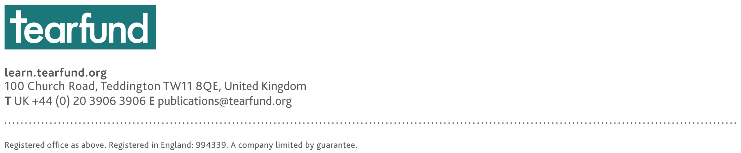

The full reference for the guide is: Daehnhardt, Madleina, and Cathy Bollaert (2021) Doing research ethically – principles and practices for international development practitioners and evaluators, Teddington/London: Tearfund and Christian Aid https://learn.tearfund.org/en/resources/tools-and-guides/doing-research-ethically https://www.christianaid.org.uk/our-work/research/capacity-development
Ibid.
Ibid.

