Participant information sheet and consent form – a two-part template

About
This participant information sheet and consent form is part of a toolkit designed to help (I)NGO practitioners apply research ethics to evidence-generating activities, including research and evaluation. The other tools in the toolkit are:
- Do research ethics apply to your project? (a checklist)
- Ethics risk assessment (a template)
- Data management plan (a template)

Figure 1 (below) shows how the tools relate to the different phases of a research or evaluation project cycle.
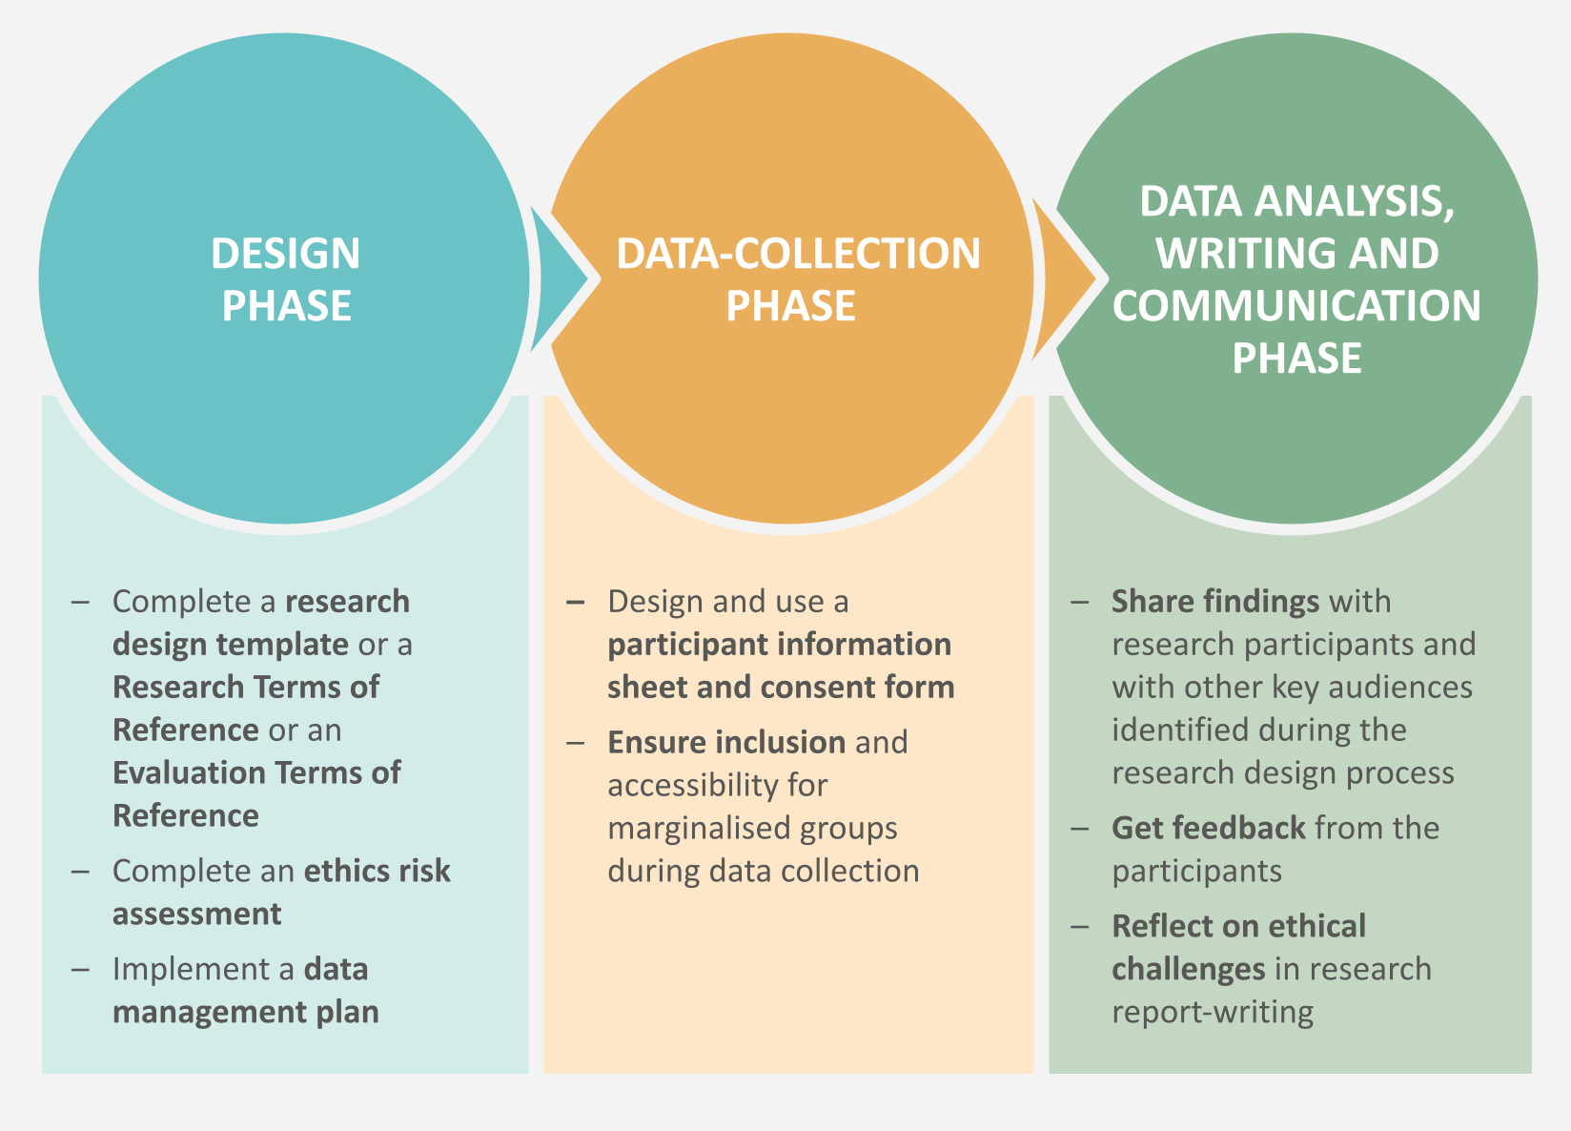

You can find the rest of the toolkit here. By following this link, you will also be able to read and download a guide to the principles that underlie the tools. Research ethics is about more than just the tools that we use: it concerns the moral integrity with which we conduct research or evaluations, and the extent to which we minimise the risk of harm associated with these activities, while maximising their benefits.

Informed consent
‘Informed consent’ is key to ethical research/evaluation. As explained in Section 2.3 of the guide, we need to understand the process of obtaining informed consent as having three steps. It is important to plan for all of them:
- providing a potential research participant with information about their involvement in the study, the rights they have as participants, and the researcher’s responsibilities towards them. This could be done using Part A of this template (the participant information sheet).
- having a discussion with the potential research participant, in order to review their understanding of the information and clarify any misunderstanding
- the research participant giving their written or verbal consent, or choosing not to do so. This could be done using Part B of this template (the consent form).

How to use
Adapt the participant information sheet for your use by taking each section in turn and replacing the prompts, written in green, with information about your research or evaluation. Getting the amount of information right is important, and is bound to vary from project to project. There needs to be enough information to ensure participants are adequately informed about the purpose and nature of the study or evaluation, but not so much that they are overwhelmed. Make sure that you use accessible, clear language, avoiding jargon or too many technical terms. It may be helpful to 'test’ the sheet for sense and clarity by reading it out to colleagues before using it with research participants.
In order to brief participants, the sheet could be read aloud to them, and their spoken agreement sought (verbal consent). Alternatively (depending on their level of literacy), the sheet could be given to them to read, with an opportunity to ask any questions; they could then be invited to sign it themselves (written consent). Depending upon the participants’ preferred language, you may need to consider translation. Even if you are seeking verbal consent, and you plan to ask an interpreter to read out the sheet, it would be better to translate it for them in advance. This will give assurance that the meaning conveyed by the interpreter is as you intended it.
Note that this document is a master template, so please ensure that you do not edit it directly. Make a copy for your own use.

PART A: Participant information sheet
The headings in this part of the template are what you might expect to see in a participant information sheet. Under each heading, examples of what information you may want to include are given in green. Please use your own words to replace the wording in green with information specific to your project.

Introductions

Add your own wording here. It could cover the following:

Who the researchers are, whom they represent (organisations and/or funders) and how they can be contacted

Invitation and explanation

Add your own wording here. It could cover the following:

How the participant is invited to take part in this piece of research (describe the interview or focus group process) and why they have been selected

An explanation of what data you are collecting from the participant and why you need it

Purpose of the study

Add your own wording here. It could cover the following:

The purpose and content of the evaluation or research

Use of data

Add your own wording here. It could cover the following:

How the data you are collecting may be used in the future, including what outputs you are planning to write (eg INGO reports, articles, training manuals, broadcasting), how photos or video footage (if taken) will be used, and who can access these outputs where

The potential for wider use of the data in the future

The potential for case studies, quotes, video footage or photos of the participant to be used for any other purpose (by your communications or fundraising teams)

Who will own the data (this may well be communities themselves) and whom you will share it with

Anonymity

Add your own wording here. It could cover the following:

A guarantee of anonymity and an assurance that no real names will be used in the write-up or use of quotes and stories, and identifiers will be removed

An assurance that if the participant does not wish to be photographed, you will take group photos from an angle that excludes them

An assurance that photos of the participant, if they are being taken, will not be used with their real name, or in a way that connects them to their words

An assurance that all the information that the participant may give about themselves will be kept safe and secure (in line with your data management plan)

Benefits and risks

Add your own wording here. It could cover the following:

The benefits (and risks, if any) of the research to individuals or communities. You need to manage the participant’s expectations here.

Compensation arrangements, ie the fact that there will be no payment for participation, but (where relevant) lunch and reimbursement for travel costs will be offered

Data recording and storage

Add your own wording here. It could cover the following:

How the participant's personal data will be stored (eg on a password-protected computer) and for how long. If you are using an audio recorder to capture the interview, explain that this is so that you can listen to it again afterwards, but that the recording will be kept private.

The fact that the participant will have the right to request their data (eg an interview transcript if one has been made)

Participation and rights to withdraw

Add your own wording here. It could cover the following:

The fact that you will not collect any data if the participant chooses to opt out. Explain that you will ask them if they are happy to take part in the study, and that they can answer ‘no’ without any negative consequences.

The fact that participants can opt out of any questions or choose not to answer or continue the interview for any reason at any time. Even if they initially give consent to participate, they can withdraw without any negative consequences.

An assurance that the participant can ask any questions about the study at any time during the interview

What you can expect from us

You could use the following wording:
All individuals involved in the study shall be treated equally, irrespective of race, ethnicity, gender, religion/or none, sexual orientation, profession, lifestyle, marital status, age, community background or disability. No one will be judged or discriminated against on the basis of any aspect of their identity.
If you feel any adverse/negative effects as a result of participating in this interview, you should report it immediately. This might include feeling bullied or harassed, unhappy about the conduct of the person interviewing you, or simply feeling more at risk as a result of participating in the interview.

Provide contact details for your safeguarding representative.
Please get in touch with:
Contact name and role:
Contact email:
Contact phone number:

Contact details

You could use the following wording:
We understand that you might change your mind in the future. You can contact us at any time if you want to withdraw from the project, if there is any information you do not want us to use, or have any questions or complaints about your participation in the project.

Provide appropriate contact details.
Please get in touch with:
Contact name and role:
Contact email:
Contact phone number:

You must be confident that arrangements for the participant to contact the researchers are practical. For example, communities who do not have access to the internet will be unable to contact the researchers by email. It may be equally inappropriate for them to pay to make a phone call to the researchers. In contrast, they may be able to speak to a representative of your organisation who regularly visits the community, who in turn may be able to pass on the feedback/complaint.

How to use Parts A and B with a participant

Once you have finished adapting Part A for your own project, and you are satisfied that it is ready for use with participants (eg it has been translated as necessary), print multiple copies of the whole document on headed paper (bearing your organisation’s logo). In order to brief a participant, read Part A aloud to them. Take time over this, allowing them to ask any questions they may have. Try to check they understand, being attentive to any ways in which they may appear to have misunderstood the information.

Part B (the consent form, below) should only be completed once the person has been given the relevant information about their participation in the research, and any questions have been answered. Read the questions in the consent form aloud, and, depending on the participant’s answers, tick ‘yes’ or ‘no’. Note that the participant will not, therefore, be asked to sign. However, the entire briefing, and the consent questions and answers, must be recorded on an audio-device.

Each participant should then be given a complete copy of Parts A and B for their future reference. You should keep a copy too. Note that this may require filling out and signing the consent form twice.

Note that the consent form is set up for verbal consent. Depending on your project and circumstances, you can adapt it for written consent.

PART B: Consent form

Consent questions:
Do you confirm that you have been given and have understood the information provided for the above study, and have asked and received answers to any questions you may have? | ▢ YES ▢ NO
Do you understand that your participation is voluntary and that you are free to withdraw at any time without giving a reason and without your rights being affected in any way? | ▢ YES ▢ NO
Do you understand that (name of organisation) _____________ will hold all information and data collected securely and in confidence, and that all efforts will be made to ensure that you cannot be identified as a participant in the study (except as might be required by law) and do you give permission for the researchers to hold relevant personal data? | ▢ YES ▢ NO
Do you agree to take part in the above study? | ▢ YES ▢ NO
Do you agree to the interview being digitally voice-recorded? | ▢ YES ▢ NO
Do you agree to photographs being taken of you, and being used in a way that will not connect you to your words in publications? | ▢ YES ▢ NO
Do you agree to the use of your words in publications without mention of your name? | ▢ YES ▢ NO
Do you agree that your information used in the study may be stored (without your name(s)) electronically, until the programme has been completed and the information is no longer required? | ▢ YES ▢ NO
Name of participant: | Date of the interview:
Location of interview:
Researcher / evaluator declaration:
I, (name of field researcher/evaluator) ______________________________________, declare that I have accurately represented and recorded the consent of the participant.

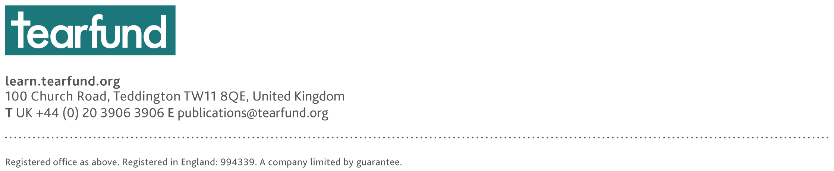

The full reference for the guide is: Daehnhardt, Madleina, and Cathy Bollaert (2021) Doing research ethically – principles and practices for international development practitioners and evaluators, Teddington/London: Tearfund and Christian Aid https://learn.tearfund.org/en/resources/tools-and-guides/doing-research-ethically https://www.christianaid.org.uk/our-work/research/capacity-development
Ibid.
SRA (2003) in Daehnhardt and Bollaert (2021)

