Ethics risk assessment template

About
This ethics risk assessment template is part of a toolkit designed to help (I)NGO practitioners apply research ethics to evidence-generating activities, including research and evaluation. The other tools in the toolkit are:
- Do research ethics apply to your project? (a checklist)
- Data management plan (a template)
- Participant information sheet and consent form (a two-part template)

Figure 1 (below) shows how the tools relate to the different phases of a research or evaluation project cycle.
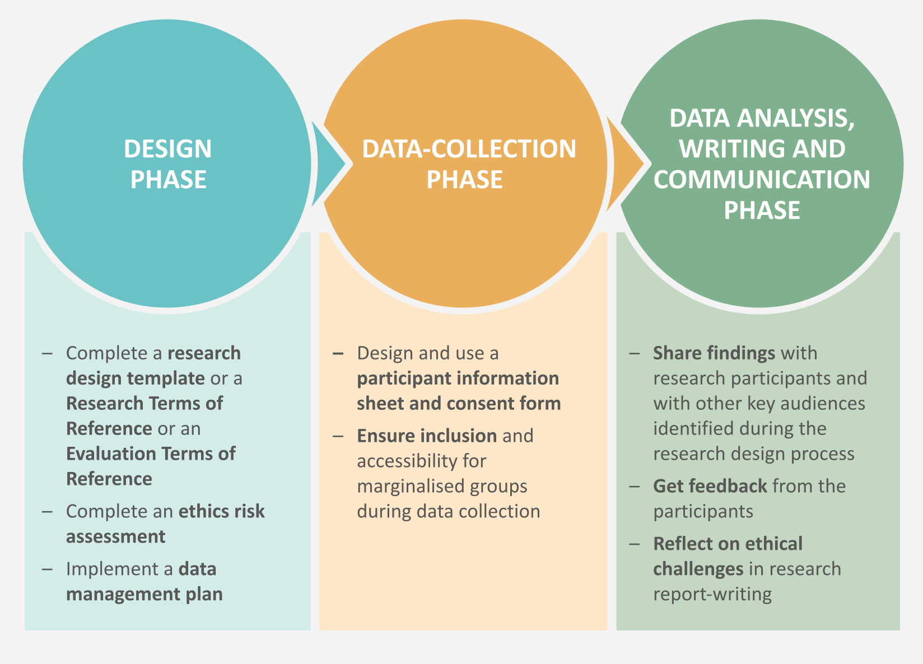

You can find the rest of the toolkit here. By following this link, you will also be able to read and download a guide to the principles that underlie the tools. Research ethics is about more than just the tools that we use: it concerns the moral integrity with which we conduct research or evaluations, and the extent to which we minimise the risk of harm associated with these activities, while maximising their benefits.

Assessing and mitigating ethical risks
As explored in the guide, conducting research or an evaluation carries with it multiple potential risks to the participants and enumerators/researchers. An ethics risk assessment, completed during the research or evaluation design phase, provides a useful way to identify these risks and develop a mitigation strategy. Not only does this ensure that ‘Do No Harm’ principles are built into the research or evaluation, but it also helps improve the integrity and quality of the data. If your organisation has a project-level safeguarding risk assessment, we would recommend carrying it out alongside the ethics risk assessment.

How to use
First, refer to Section 1.2 of the guide for recommendations as to who should be involved in completing an ethics risk assessment. Risk assessments are only as good as the people involved in them, and different people will see different ethical issues in the same piece of research. Broad consultation is recommended.
Next, refer to the tool itself, where you will find a series of questions. Consider each of these in turn: they will help you identify the ethical risks (actual or anticipated) associated with your research or evaluation project. Further prompts are written in green: they will help you to describe the identified risks and then identify ways of mitigating them. Replace the green text with normal text as you are completing the assessment.
This document is a master template, so please ensure that you do not edit it directly. Make a copy for your own use.

Question | Assessment of risk | Mitigation strategy
Does your project involve working with children, people under 18 years or vulnerable adults?  See Section 4 of the guide. | If yes, state which groups are included in your research (eg adolescent people living with disabilities).  List the additional risks they might face in relation to their safety, inclusion and participation (eg ability to access interview location). | Examples include:  - Ensure all the facilities have disability access.  - Seek informed consent from a parent/guardian.  - Ensure safer working practices such as not working alone with participants.  - Check if researchers need to have a criminal background check or similar.
Does your project involve engagement with marginalised and/or stigmatised groups?  See Section 4 of the guide. | If yes, state which groups are included in your research (eg victims of SGBV).  What risks are associated with working with this group? (eg risk of individuals being identified, which risks further victimisation)  What are the risks associated with your choice of research methods and data collection? (eg participants might not trust you enough to give you the information and data you need) | Examples include:  - Conduct workshops with researchers/evaluators and partner organisations to raise awareness about the complexities of SGBV.  - Conduct interviews in private settings.  - Make sure the researchers/evaluators are female if interviewing females.  - Ensure participants understand how their data will be kept private.  - Consider ways of compensating your research participants for their time and inputs.
Are you engaging with sensitive topics?  See Section 4 of the guide. | If yes, state which topics (eg research on gender-based violence; experiences of conflict; experiences of local government service provisions; topics of faith, religion or church)  What are the risks associated with the topic(s) and research methods? (eg risk of causing distress or re-traumatisation; increase in domestic violence) | Examples include:  - Provide participants with a list of relevant referral services.  - Make sure the researchers are aware of the broader political context, social and cultural norms.  - Discuss with researchers/evaluators how to respond in the event that someone shows signs of distress.  - Carry out interviews in a private and safe space.
Is there clarity on information and consent procedures?  See the participant information sheet and consent form, another of the tools in the toolkit. | Explain how you will go about gaining informed consent from your participants (eg over the telephone, face to face etc).  What risks does your selected process pose to people living with disabilities and other marginalised groups? (eg how will a person who is hard of hearing or who is partially sighted be able to give consent?)  How (if at all) does the individualised consent process contradict the need for collective consent? | Examples include:  - Explain clearly how you are going to use this data and in a language/method that is appropriate to that individual.  - Consider giving the research participants time to discuss the research/process with their family members.  - Read out the participant information sheet and consent form.  - Where appropriate, record consent verbally.  - Keep a record of participants' consent.  - Inform participants that they can withdraw their consent at any time.  - Ensure participants have a way of contacting you and you have a way of contacting them – if what you are doing with the data changes.  - Consider the option of group consent in the case of participatory/action research.
Is there clarity on anonymity and confidentiality?  See Sections 2.5 and 3.1 of the guide. | What risks do your research and chosen research methods pose to participant confidentiality and anonymity? (eg how will you ensure any electronic or hard copies of the consent form or interview transcripts are not lost, visible to others or stolen?) | Examples include:  - Implement a data management plan (another of the tools in the toolkit).  - Don’t use actual names: use pseudonyms or letters for people.  - Only collect personal information that is necessary.
What power relations are represented in your research?  See Section 3.2 of the guide. | How do the different aspects of your identity interact with the identities of the research participants? (eg race, gender, age, class, disability, ethnicity, nationality etc)  What risks does your identity pose to the quality of the data and how you interpret the findings? (eg participants might not trust you enough to provide you with honest and in-depth responses)  How does your research seek to engage with, or employ, local intermediaries (interpreters, researchers, gatekeepers), and what is their role in the research?  How might the use of specific research tools or methods improve or undermine local research capacity? | Examples include:  Identify and explain the different power relationships that exist, including those within the community.  Explain how you might mitigate those power dynamics (such as separating respondents into different groups).  Select researchers/evaluators who already have a relationship with the participants.  Select alternative researchers if you consider their pre-existing relationships might influence data collection and analysis.  Avoid the use of data-collection methods that may displace or undermine field-based, local researchers.  Reflect on how your biases might influence how you interpret the data.
What (security/harm) risks does the research pose to the participants and do you have appropriate referral mechanisms in place? | Examples include:  physical risks: eg illness, community violence, hunger due to taking people away from their farming/labour  social risks: eg causing a group of people to be exposed to further stigma or social isolation  psychological risks: eg reminding people of traumatic events, allowing people to be harassed, bullied or to feel ashamed  safeguarding and protection risks: eg exploitation; sexual, emotional and physical abuse; sexual harassment  - political risks: eg risks from authorities and power-holders. | Examples include:  Before conducting an interview or a survey, first make sure participants are in a safe space. If necessary, make new arrangements to meet or call the participants.  Provide participants with a card that lists information about referral services in their area. (These should be assessed for disability access.)  Include contact information for feedback and complaints on your participant information sheet.  Provide safeguarding training for your evaluators/researchers and ask them to sign your organisation's code of conduct.  Ensure people do not work alone.
What (security/harm) risks does the research pose to the researcher or evaluator? | Examples include:  physical risks: eg traffic accidents en route to the research location, illness, community tensions and violence  social risks: eg reputational damage  psychological risks: eg secondary trauma  safeguarding and protection risks: eg exploitation; sexual, emotional and physical abuse; sexual harassment. | Examples include:  Follow your organisation's safeguarding procedures and mechanism for reporting any adverse incidents (including safeguarding and protection incidents).  Carry out a security risk assessment plan.  Consider the various security concerns and risks, particularly in politically constrained environments.
What (security/harm) risks does the research pose to the data? | Examples include:  the risk of accidentally losing your data or it getting stolen  the risk of a breach of confidentiality and data being shared or seen by others outside the research or evaluation team. | Examples include:  Implement a data management plan (another of the tools in the toolkit).  Train researchers/evaluators on managing data responsibly.  Train researchers/evaluators on how to use the data-collection tools.  Ensure those associated with your data understand what it is used for.
Is your research or evaluation conflict-sensitive? | What is the risk of the research contributing to fuelling community tensions?  How does the research or evaluation interact with the issues driving the conflict and/or the fragility of the community?  What is the position of stakeholders in relation to the conflict?  What cultural values or beliefs are carried through the research and how are these the same as or different from those held in the local context? | Examples include:  Carry out or update your conflict analyses.  Consider working with stakeholders who collectively are representative of the community.  Review your research tools to ensure they are appropriate to the social, cultural, security and geographic context.
What local or national legal and ethical requirements does your research need to comply with? | Examples include:  General Data Protection Regulation (GDPR)  child-protection and safeguarding policies  ethical guidelines for health research. | Examples include:  Complete your organisation’s training on GDPR, safeguarding and child protection (as applicable).  Check with local authorities about ethical approval processes in the country where you are working and say how you will adhere to these.

The full reference for the guide is: Daehnhardt, Madleina, and Cathy Bollaert (2021) Doing research ethically – principles and practices for international development practitioners and evaluators, Teddington/London: Tearfund and Christian Aid https://learn.tearfund.org/en/research-and-policy/how-we-research https://www.christianaid.org.uk/our-work/research/capacity-development
Ibid.
Doherty et al. (2017) in Daehnhardt and Bollaert (2021)
Adapted from Christian Aid’s ‘Template for commissioning a research or evaluation project’

